**Exercise 1: Inventory Management System**

**Scenario:**

You are developing an inventory management system for a warehouse. Efficient data storage and retrieval are crucial.

**Steps:**

1. **Understand the Problem:**
   * Explain why data structures and algorithms are essential in handling large inventories.
   * Discuss the types of data structures suitable for this problem.
2. **Setup:**
   * Create a new project for the inventory management system.
3. **Implementation:**
   * Define a class Product with attributes like **productId**, **productName**, **quantity**, and **price**.
   * Choose an appropriate data structure to store the products (e.g., ArrayList, HashMap).
   * Implement methods to add, update, and delete products from the inventory.
4. **Analysis:**
   * Analyze the time complexity of each operation (add, update, delete) in your chosen data structure.
   * Discuss how you can optimize these operations.

Ans:

Efficient data storage and retrieval are crucial in inventory management for the following reasons:

* Proper data structures and algorithms ensure fast access, modification, and storage of inventory data.
* As the inventory grows, efficient data handling ensures the system can scale without any fail.
* Organized data structures make easier to maintain and update the inventory system.

Types of data structures suitable for inventory management system are:

1. Array: In this data structure elements can be accessed quickly by index. However, insertion and deletion can be costly.
2. Hash Map: Average O(1) time complexity for insertions, deletions, and lookups makes perfect data structure for inventory management system.

**Setup:**

We can create a file named “Inventorymanagementsystem”.

**Implementation:**

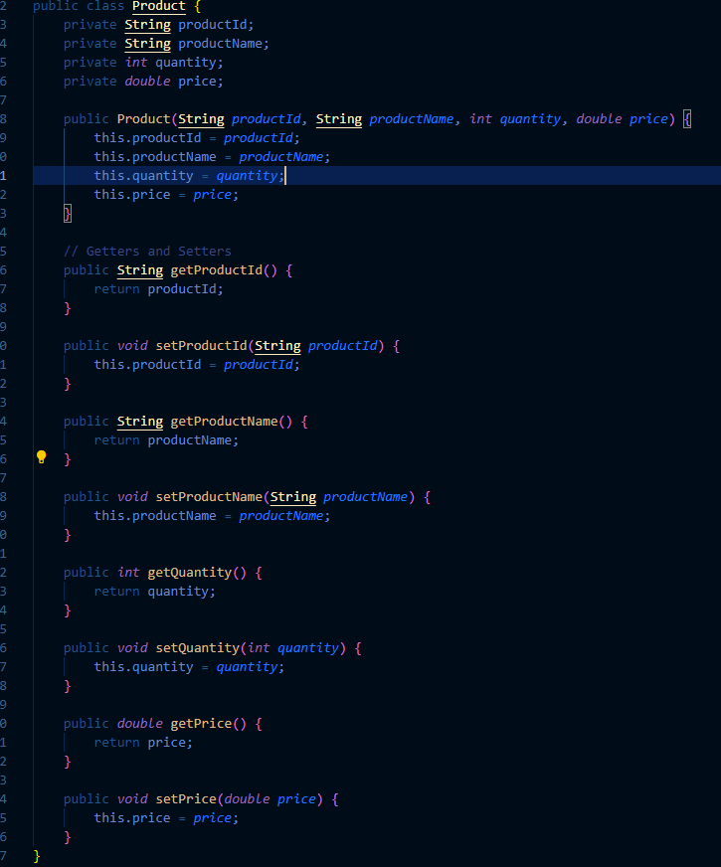

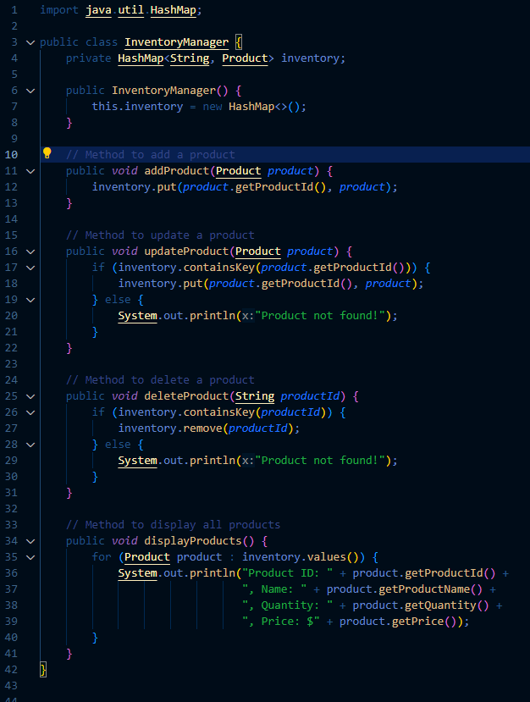

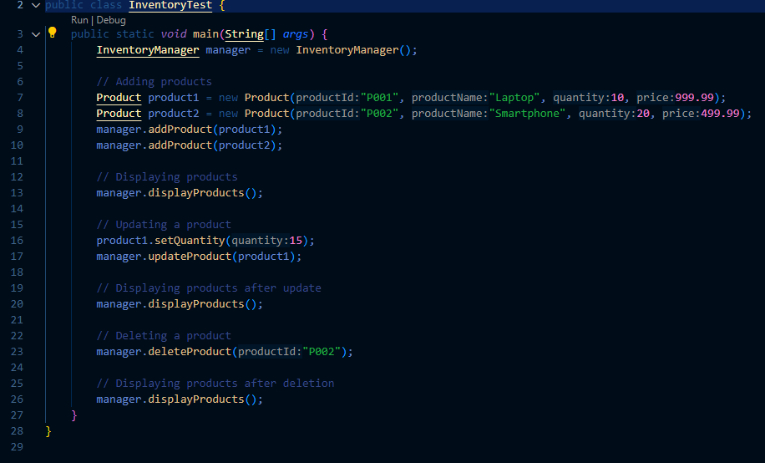

**Analysis:**

Since we are using Hash map so the time complexity of insertion, deletion and other operations take O(1).

**Exercise 2: E-commerce Platform Search Function**

**Scenario:**

You are working on the search functionality of an e-commerce platform. The search needs to be optimized for fast performance.

**Steps:**

1. **Understand Asymptotic Notation:**
   * Explain Big O notation and how it helps in analyzing algorithms.
   * Describe the best, average, and worst-case scenarios for search operations.
2. **Setup:**
   * Create a class **Product** with attributes for searching, such as **productId, productName**, and **category**.
3. **Implementation:**
   * Implement linear search and binary search algorithms.
   * Store products in an array for linear search and a sorted array for binary search.
4. **Analysis:**
   * Compare the time complexity of linear and binary search algorithms.
   * Discuss which algorithm is more suitable for your platform and why.

**Ans:**

Big O notation is a mathematical notation used to describe the upper bound of an algorithm's running time. It provides an upper limit on the time (or space) complexity as a function of the input size, which helps in analyzing the efficiency and scalability of algorithms.

1. O(1): Constant time complexity - the algorithm's performance is not affected by the input size.
2. O(n): Linear time complexity - the algorithm's running time increases linearly with the input size.
3. O(log n): Logarithmic time complexity - the algorithm's running time increases logarithmically with the input size.
4. O(n^2): Quadratic time complexity - the algorithm's running time increases quadratically with the input size.

Best, Average, and Worst-Case Scenarios

* Best Case: The scenario where the algorithm performs the minimum number of operations (e.g., finding the element immediately).
* Average Case: The scenario where the algorithm performs a moderate number of operations (e.g., element is in the middle of the list).
* Worst Case: The scenario where the algorithm performs the maximum number of operations (e.g., element is at the end of the list or not present).

Setup:

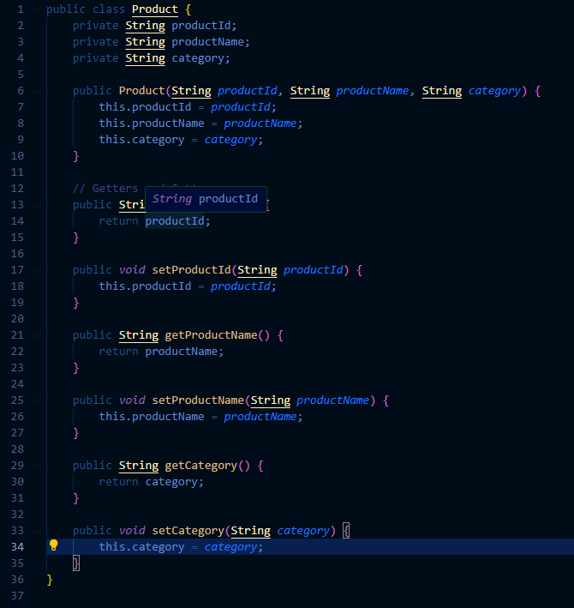

**Implementation:**

Linear Search

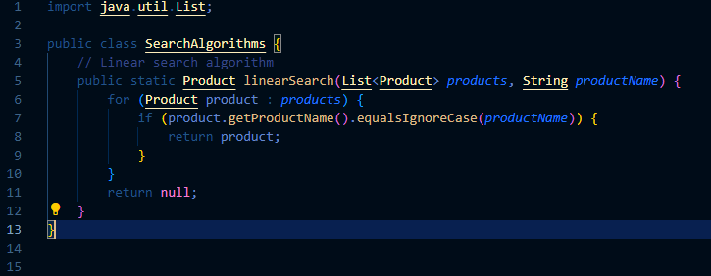

Binary Search

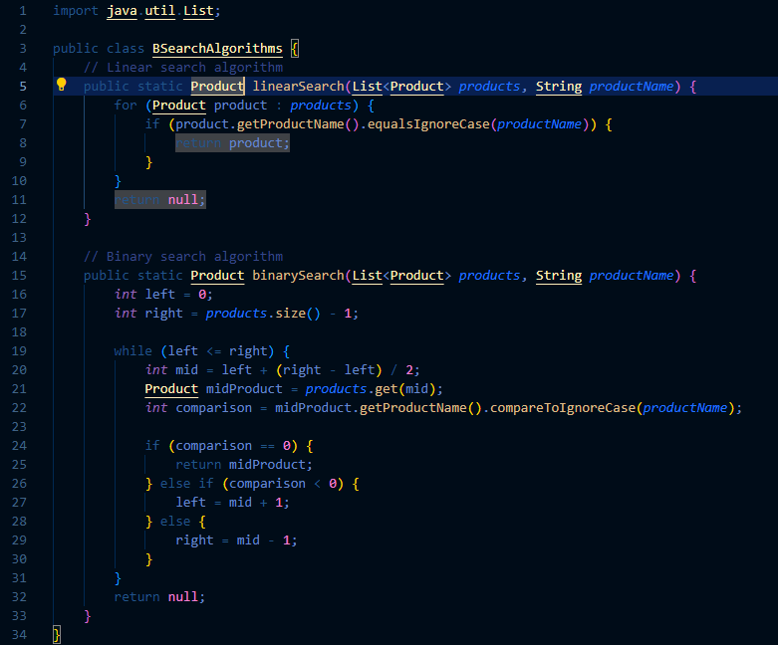

Using Linear Search and Binary Search

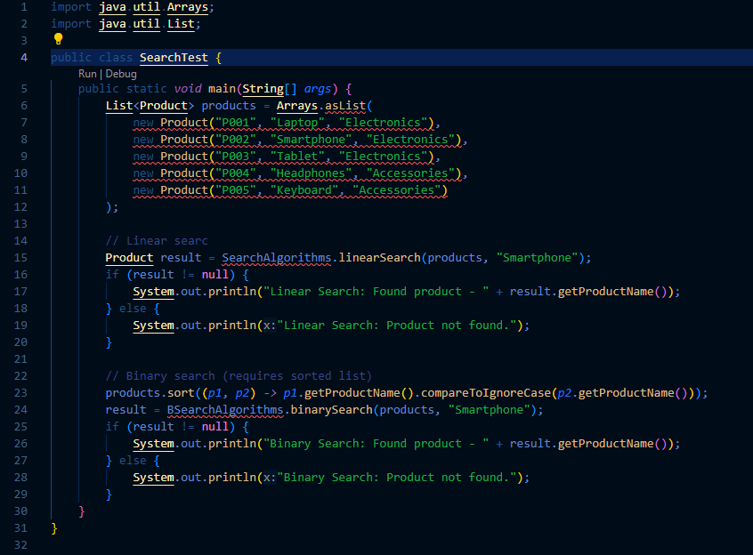

**Analysis**

Time Complexity

* Linear Search: The time complexity is O(n) in the worst and average cases because it may need to check each element in the list.
* Binary Search: The time complexity is O(log n) in the worst and average cases because it repeatedly divides the search interval in half.

**Exercise 3: Sorting Customer Orders**

**Scenario:**

You are tasked with sorting customer orders by their total price on an e-commerce platform. This helps in prioritizing high-value orders.

**Steps:**

1. **Understand Sorting Algorithms:**
   * Explain different sorting algorithms (Bubble Sort, Insertion Sort, Quick Sort, Merge Sort).
2. **Setup:**
   * Create a class **Order** with attributes like **orderId**, **customerName**, and **totalPrice**.
3. **Implementation:**
   * Implement **Bubble Sort** to sort orders by **totalPrice**.
   * Implement **Quick Sort** to sort orders by **totalPrice**.
4. **Analysis:**
   * Compare the performance (time complexity) of Bubble Sort and Quick Sort.
   * Discuss why Quick Sort is generally preferred over Bubble Sort.

Ans:

**Bubble Sort**

Bubble Sort is a simple comparison-based sorting algorithm. It repeatedly steps through the list, compares adjacent elements, and swaps them if they are in the wrong order. This process is repeated until the list is sorted.

**Insertion Sort**

Insertion Sort builds the sorted array one element at a time by repeatedly picking the next element and inserting it into the correct position within the sorted part of the array.

**Quick Sort**

Quick Sort is a divide-and-conquer algorithm. It works by selecting a 'pivot' element from the array and partitioning the other elements into two sub-arrays, according to whether they are less than or greater than the pivot. It then recursively sorts the sub-arrays.

**Merge Sort**

Merge Sort is also a divide-and-conquer algorithm. It divides the array into two halves, sorts each half, and then merges the sorted halves back together.

**Setup:**

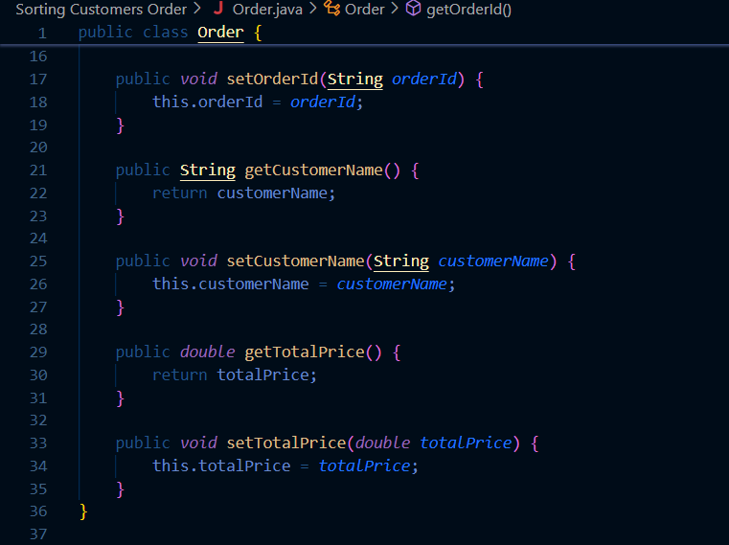

**Implementation:**

Quick Sort

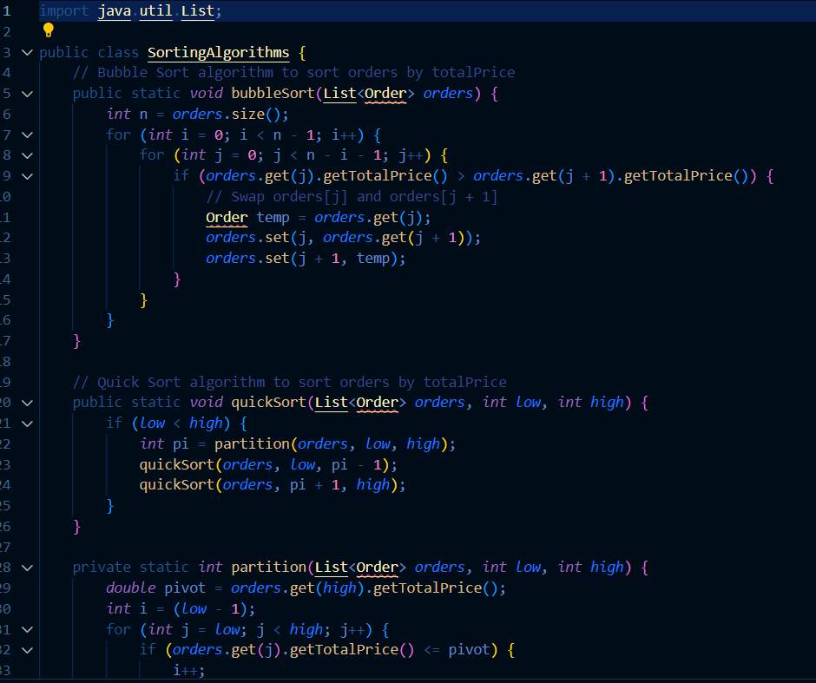

**Analysis:**

Quick Sort is generally preferred over Bubble Sort for several reasons:

* Quick Sort is significantly faster on average due to its O(n log n) average-case time complexity, compared to Bubble Sort's O(n^2) average-case time complexity.
* Quick Sort handles larger datasets more efficiently.
* Quick Sort is an in-place sort (does not require additional memory proportional to the input size), making it more memory-efficient than some other algorithms like Merge Sort.

**Exercise 4: Employee Management System**

**Scenario:**

You are developing an employee management system for a company. Efficiently managing employee records is crucial.

**Steps:**

1. **Understand Array Representation:**
   * Explain how arrays are represented in memory and their advantages.
2. **Setup:**
   * Create a class Employee with attributes like **employeeId**, **name**, **position**, and **salary**.
3. **Implementation:**
   * Use an array to store employee records.
   * Implement methods to **add**, **search**, **traverse**, and **delete** employees in the array.
4. **Analysis:**
   * Analyze the time complexity of each operation (add, search, traverse, delete).
   * Discuss the limitations of arrays and when to use them.

Ans:

**Array Representation in Memory**

Arrays are a collection of elements stored in contiguous memory locations. This means that the elements of the array are stored next to each other in memory. The index of the array elements starts at 0 and goes up to n-1, where n is the number of elements in the array.

**Advantages of Arrays**

1. Arrays allow direct access to elements using their index, which makes retrieval very fast (O(1) time complexity).
2. Since arrays have a fixed size, the memory allocation is predictable.
3. Contiguous memory allocation makes arrays cache-friendly, improving performance.

Setup:

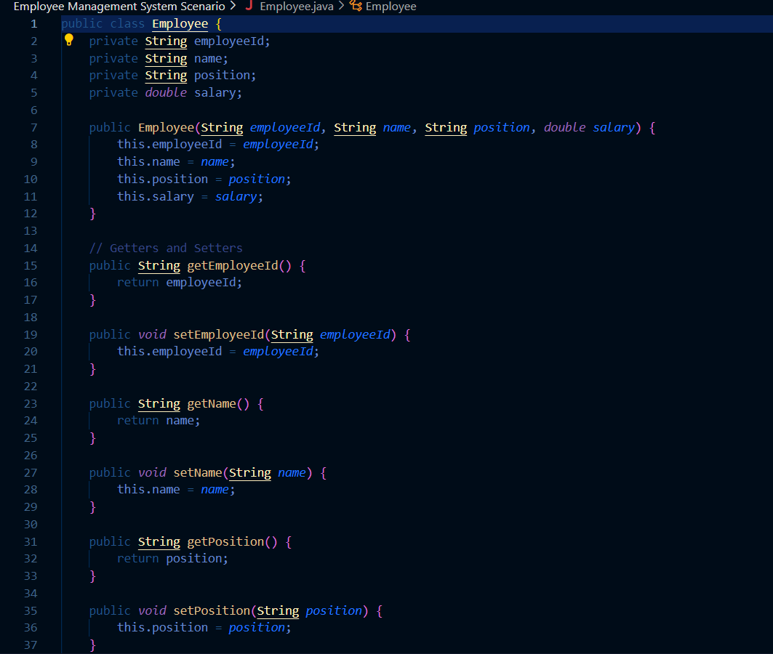

Implementation:

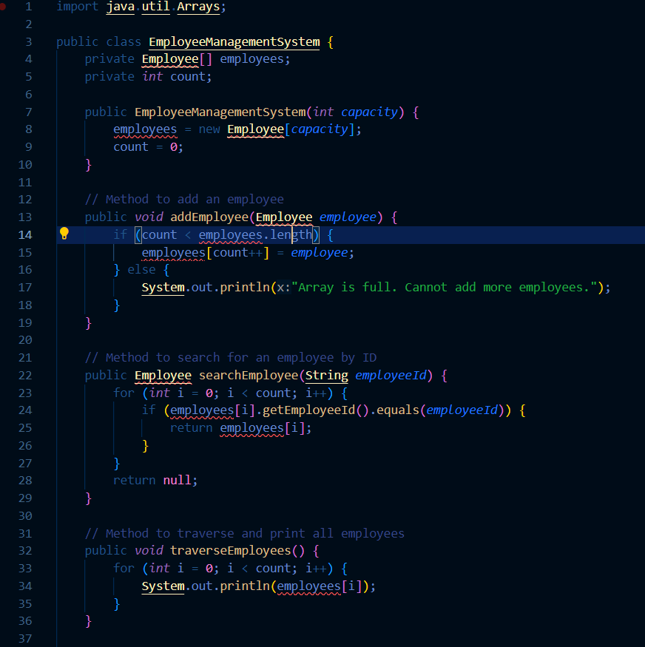

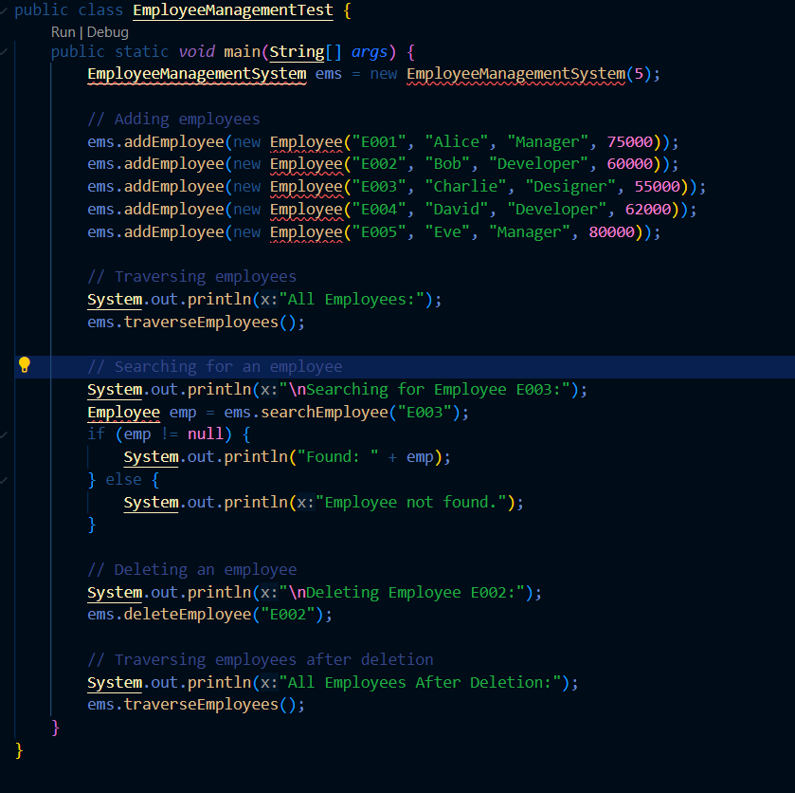

**Exercise 5: Task Management System**

**Scenario:**

You are developing a task management system where tasks need to be added, deleted, and traversed efficiently.

**Steps:**

1. **Understand Linked Lists:**
   * Explain the different types of linked lists (Singly Linked List, Doubly Linked List).
2. **Setup:**
   * Create a class **Task** with attributes like **taskId**, **taskName**, and **status**.
3. **Implementation:**
   * Implement a singly linked list to manage tasks.
   * Implement methods to **add**, **search**, **traverse**, and **delete** tasks in the linked list.
4. **Analysis:**
   * Analyze the time complexity of each operation.
   * Discuss the advantages of linked lists over arrays for dynamic data.

Ans:

**Types of Linked Lists**

1. **Singly Linked List:**
   * Each node contains data and a reference (or link) to the next node in the sequence.
   * The last node points to null, indicating the end of the list.
   * Operations like insertion and deletion at the beginning of the list are efficient (O(1)), but accessing an element by index requires O(n) time complexity.
2. **Doubly Linked List:**
   * Each node contains data, a reference to the next node, and a reference to the previous node.
   * Allows traversal in both directions (forward and backward).
   * Insertion and deletion operations are efficient (O(1)), but accessing an element by index still requires O(n) time complexity.

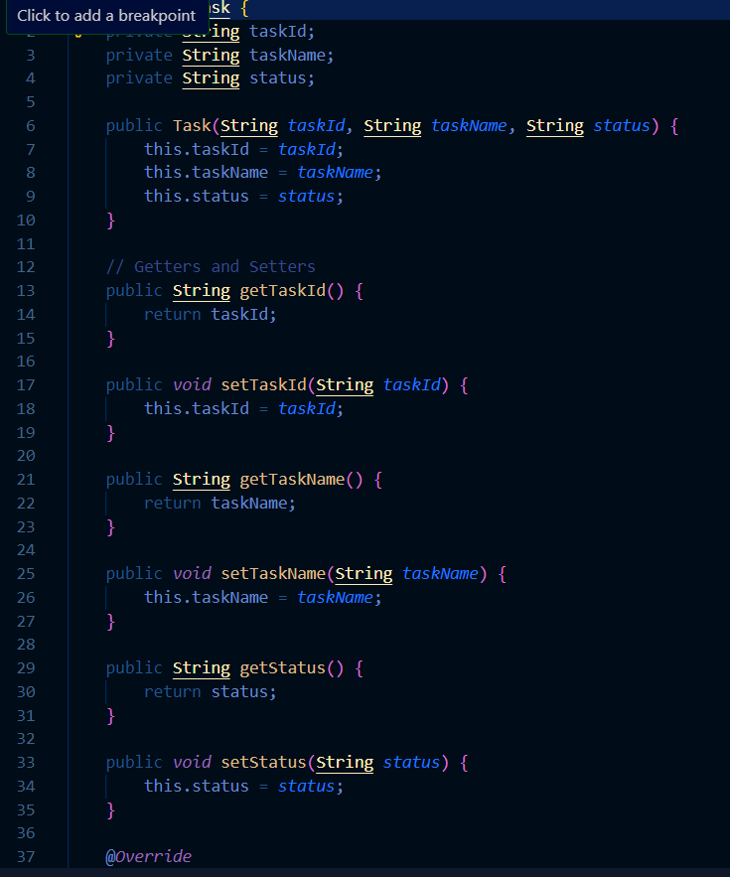

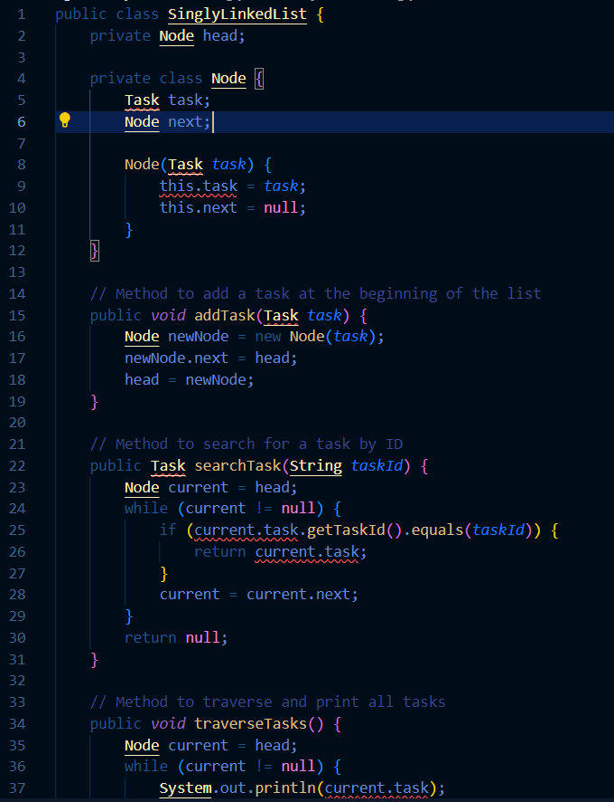

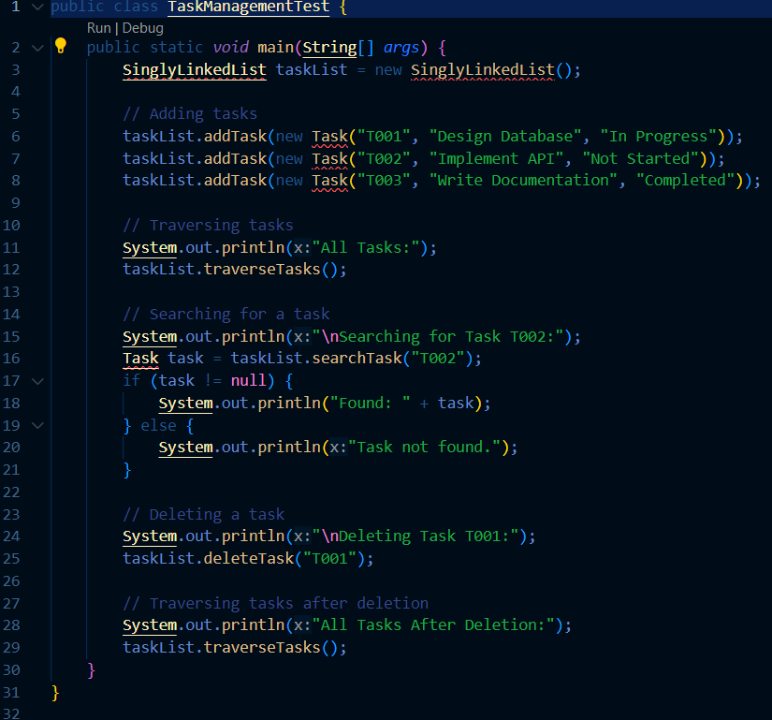

**Time Complexity Analysis**

* O(1) - Adding a task at the beginning of the list is a constant time operation.
* O(n) - In the worst case, we may need to search through all tasks.
* O(n) - We need to traverse all n tasks.
* O(n) - In the worst case, we may need to search through all tasks to find the one to delete.

**Exercise 6: Library Management System**

**Scenario:**

You are developing a library management system where users can search for books by title or author.

**Steps:**

1. **Understand Search Algorithms:**
   * Explain linear search and binary search algorithms.
2. **Setup:**
   * Create a class **Book** with attributes like **bookId**, **title**, and **author**.
3. **Implementation:**
   * Implement linear search to find books by title.
   * Implement binary search to find books by title (assuming the list is sorted).
4. **Analysis:**
   * Compare the time complexity of linear and binary search.
   * Discuss when to use each algorithm based on the data set size and order.

Ans:

**Linear Search**

* **Definition:** Linear search is a straightforward search algorithm that checks each element in a list sequentially until the desired element is found or the end of the list is reached.
* **Time Complexity:** O(n) in the worst case, where n is the number of elements in the list.

**Binary Search**

* **Definition:** Binary search is an efficient algorithm that works on sorted lists. It repeatedly divides the list into halves, comparing the target value with the middle element, and continues in the half where the target could be.
* **Time Complexity:** O(log n) in the worst case, where n is the number of elements in the list.

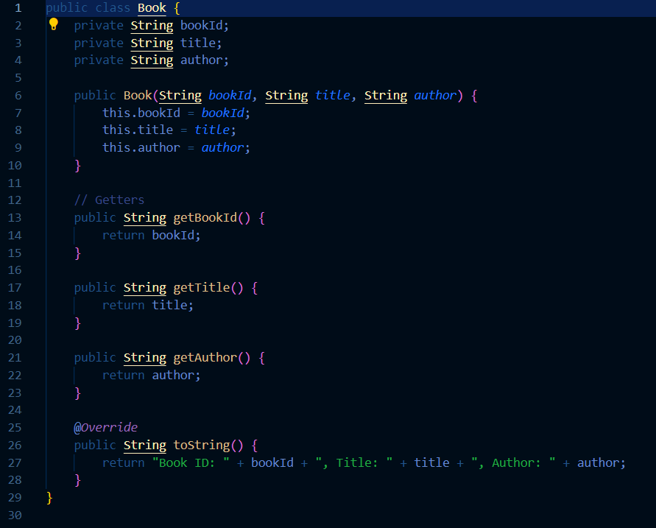

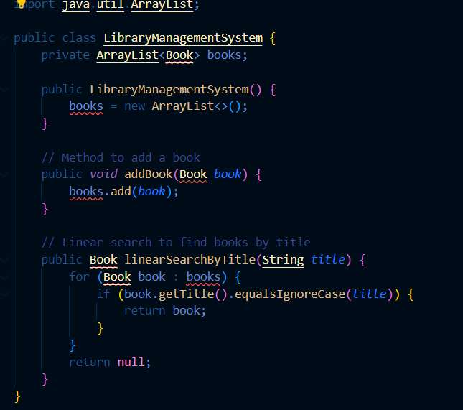

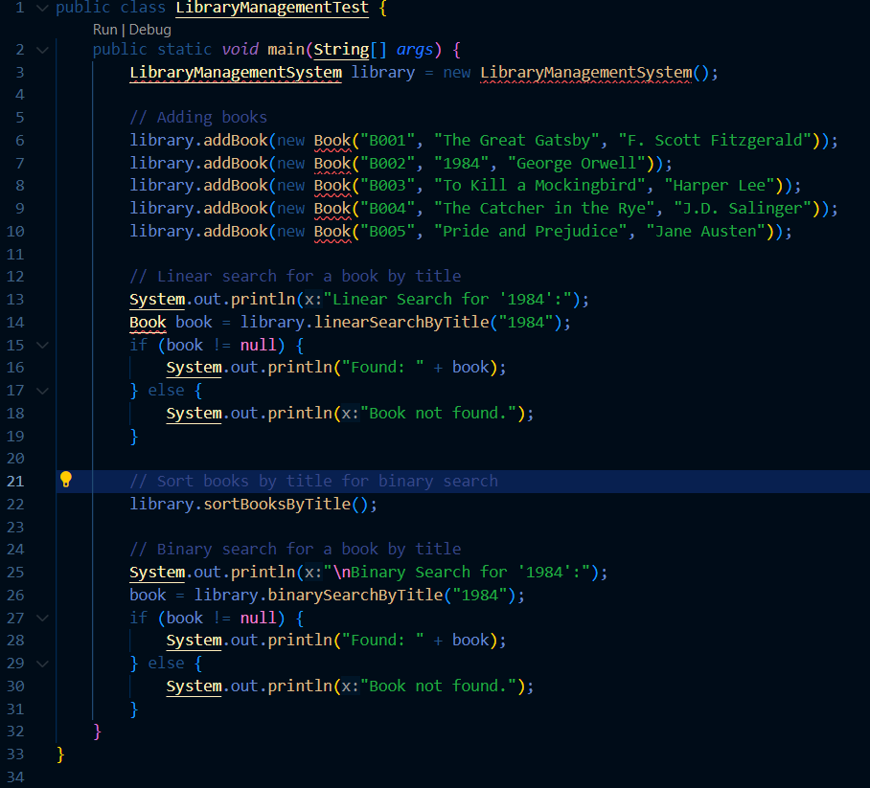

**Time Complexity Comparison**

* Linear Search: O(n) - Each element is checked until the desired element is found or the end of the list is reached.
* Binary Search: O(log n) - The list is repeatedly divided in half until the desired element is found or the sub-list size becomes zero.

**Exercise 7: Financial Forecasting**

**Scenario:**

You are developing a financial forecasting tool that predicts future values based on past data.

**Steps:**

1. **Understand Recursive Algorithms:**
   * Explain the concept of recursion and how it can simplify certain problems.
2. **Setup:**
   * Create a method to calculate the future value using a recursive approach.
3. **Implementation:**
   * Implement a recursive algorithm to predict future values based on past growth rates.
4. **Analysis:**
   * Discuss the time complexity of your recursive algorithm.
   * Explain how to optimize the recursive solution to avoid excessive computation.

Ans:

**Concept of Recursion**

* **Definition:** Recursion is a process in which a function calls itself directly or indirectly. It solves a problem by breaking it down into smaller, more manageable sub-problems of the same type.
* **Advantages:** Recursion can simplify the implementation of certain algorithms by reducing complex problems to simpler base cases.

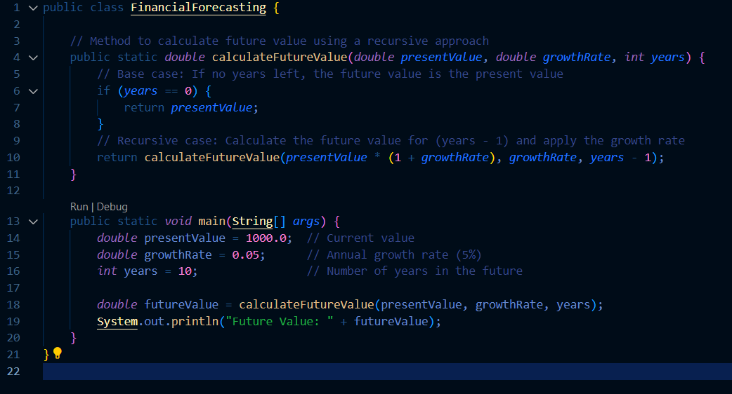

**Analysis**

**Time Complexity of Recursive Algorithm**

* **Time Complexity:** O(n) - The algorithm makes a recursive call for each year, resulting in a linear time complexity with respect to the number of years.